1. Find the bugs in the following apps
   1. ***Calculator***

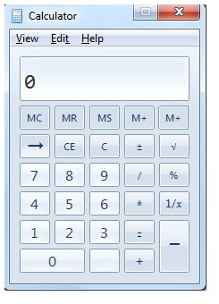

Bug 1.

1. Go to the calculator app
2. Tap 8
3. Tap the button between the ”0” digit and “+” sign
4. Tap 4
5. Observe the result

Expected result:

* By tapping the button between the ”0” digit and “+” sign to establish an action.

Actual result:

* There is no availability for making an action by clicking on the already mentioned button. There is no way to understand what is the purpose of the button.

Test Case 1.

1. Go to the calculator app
2. Find “+” sign
3. Observe the result

Expected result:

* To be able to find one button with “+” sign

Test Case 2.

1. Go to the calculator app
2. Find “/” sign
3. Observe the result

Expected result:

- To be able to find one button with “/” sign

Bug 2.

1. Go to the calculator app
2. Minimize the app by pressing the “_” button in the right upper corner
3. Observe the result

Expected results:

* To be able to minimize the app by pressing the already mentioned button

Actual result:

* There is no such button in the right upper corner

***1.2 Calendar***

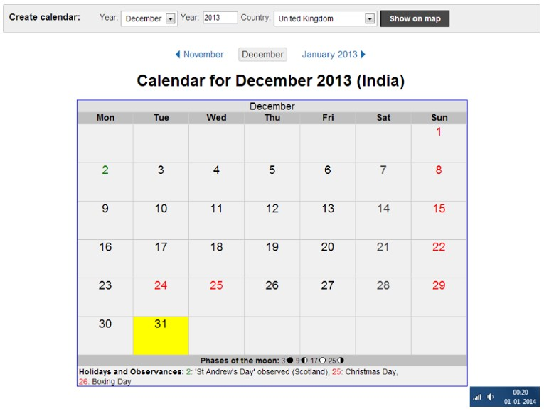

Bug 1.

1. Go to the calendar app
2. Search the calendar for UK from the appropriate option
3. Click on “Show on map” button
4. Observe the result

Expected result:

* After clicking on “Show on map” button to be able to see calendar for United Kingdom

Actual result:

* Searching the calendar for UK leads you to the calendar for India

Bug 2.

Steps to reproduce:

1. Go to the calendar app
2. Search the calendar for 01.01.2014
3. Observe the result

Expected result:

* If the user of the app searches calendar for the already mentioned date the normal thing is to see such calendar on the screen

Actual result:

* Searching the calendar for 01.01.2014 leads you to a calendar for 31.12.2013 as a result

***Lack of information***

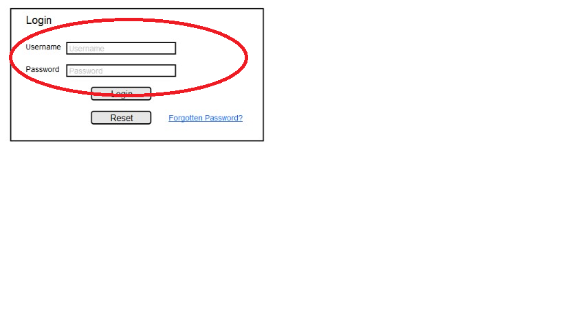

***Review the specification***

The “App” is a GPS-based mobile application which helps people to find the closest restaurants based on the user’s current position and other specification like price, restaurant type, dish and more. The application should be free to download from either a mobile phone application store or similar services. Restaurant owners can provide their restaurant information using the web-portal. This information will act as the bases for the search results displayed to the user. An administrator also uses the web-portal in order to administer the system and keep the information accurate. The administrator can, for instance, verify restaurant owners and manage user information. Furthermore, the software needs both Internet and GPS connection to fetch and display results. All system information is maintained in a database, which is located on a web-server. The software also interacts with the GPS-Navigator software which is required to be an already installed application on the user’s mobile phone. By using the GPS-Navigator, users can view desired restaurants on a(the) map and be navigated to them. The application also has the capability of representing both summary and detailed information about the restaurants.

